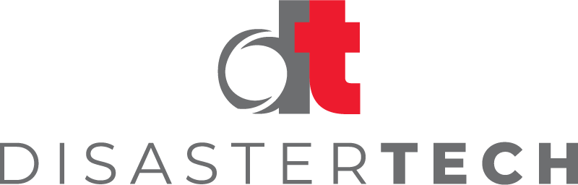

Disaster Tech Now Certified as a B Corporation by B Lab Global

Alexandria, VA: On February 2, 2022, Disaster Tech, Inc. was named a Certified B Corporation by B Lab Global. B Corporation Certifications are given to businesses that meet high standards of verified performance, accountability, and transparency on factors from employee benefits and charitable giving to supply chain practices and input materials.
The requirements for a business to become a Certified B Corporation start with exhibiting high social and environmental performance through attaining a B Impact Assessment score of 80 or above or passing B Lab’s risk review. The company applying must make a legal allegiance by changing their corporate governance structure to be accountable to all stakeholders and achieve benefit corporation status if available in their jurisdiction. Lastly, the company must exhibit transparency by allowing information about their performance measured against B Lab’s standards to be publicly available on their B Corp profile on B Lab’s website.
"Disaster Tech is honored to be named a B Corporation by B Lab. We are predicated with B Corp’s mission on the basis of our mission to save lives, protect the environment, and build resilience.” stated CEO of Disaster Tech, Sean Griffin.
To visit Disaster Tech’s B Corporation profile, visit www.bcorporation.net/en-us/find-a-b-corp/company/disaster-techf

About B Lab
B Lab is a nonprofit network transforming the global economy to benefit all people, communities, and the planet. B Lab is known for certifying B Corporations, which are companies that meet high standards of social and environmental performance, accountability, and transparency. To learn more about B Lab, visit www.bcorporation.net.
About Disaster Tech
Disaster Tech, a veteran-owned public benefit company, offers decision science technologies for situational awareness, operational coordination, and risk management before, during, and after disasters. Disaster Tech's goal is to save lives, protect the environment, and build resilient communities by providing the most sophisticated, advanced analytics and distributed high-performance computing platform on the planet. Find more at www.disastertech.com.
Disaster Tech Media Contact:
Jaclyn Silvestri
Jaclyn@disastertech.com

